Year 2 Curriculum at Hounslow Town Primary School
At Hounslow Town Primary School, we are pleased to present our vibrant Year 2 curriculum, designed to align with national educational guidelines while offering engaging learning experiences. Our pupils explore a wide range of topics throughout the year, facilitating both academic and personal development in accordance with the Year 2 National Curriculum.
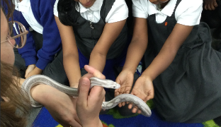
The term begins with an exciting Zoo Lab workshop, where children encounter a variety of animals, including giant African snails and snakes. They explore the habitats and diets of these creatures and have the unique opportunity to hold some. This interactive session effectively complements our science objectives.
Another highlight is Pirate Day, during which children don pirate costumes and engage in themed activities that ignite creativity. This fun event weaves together elements of history, geography, science, and the arts, reinforcing essential skills within the curriculum.
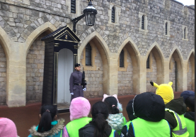
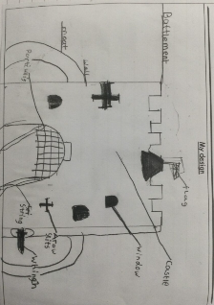
A visit to Windsor Castle enhances our pupils' understanding of history, allowing them to view artefacts and learn about royal life. They are also encouraged to design and create their own sections of a castle, promoting creative application of their knowledge.
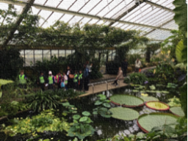
The trip to Kew Gardens offers children the chance to explore a diverse range of plants and animals, directly linking to their science curriculum. This hands-on experience enriches their understanding of biodiversity and instils respect for nature.
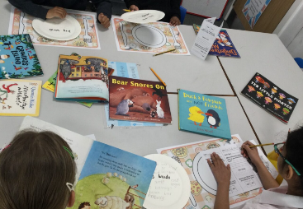
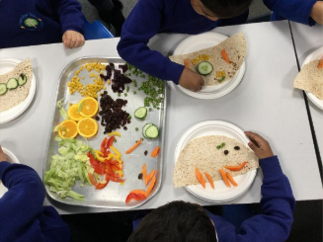
We also celebrate World Book Day, where children wear imaginative costumes and participate in enjoyable activities, including book tasting and quizzes. Our streamed reading sessions are tailored to individual levels, fostering a lifelong love of reading.
In PSHE lessons, our Healthy Food Workshop, led by a nutritionist from our catering company, teaches children about the importance of a balanced diet and healthy eating habits, aligning with our health education objectives.
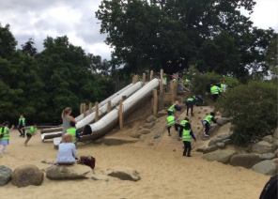
Throughout the year, pupils develop maths skills using manipulatives and simple word problems, solidifying their understanding of fundamental concepts. Daily phonics sessions, following the Little Wandle scheme, ensure children build a strong foundation for reading and writing.
Our participation in Science Week allows children to explore various STEM themes, igniting their curiosity and enthusiasm for learning. The academic year concludes with a lively Sports Day, where children showcase teamwork and determination in a variety of races. This dynamic programme not only adheres to the national curriculum but also promotes a lifelong love of learning.
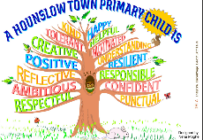
At Hounslow Town Primary School, we are committed to fostering an environment rooted in our core values. We believe that adults in our community should exemplify compassion and professionalism, creating a supportive atmosphere for all. We aim to instil resilience and motivation in our children, equipping them to embrace challenges with ambition. By promoting a culture of kindness and respect, we ensure every member of our school community feels valued and inspired. Together, we strive to cultivate personal and academic growth for each individual at Hounslow Town Primary School.

