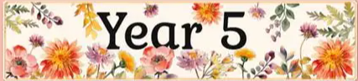
In Year 5, our pupils embark on an exciting learning journey filled with exploration, creativity, and hands-on experiences that bring the curriculum to life. Guided by our school motto — to encourage, to inspire, to learn, to achieve — we aim to provide a supportive and stimulating environment where every child feels motivated to reach their full potential.
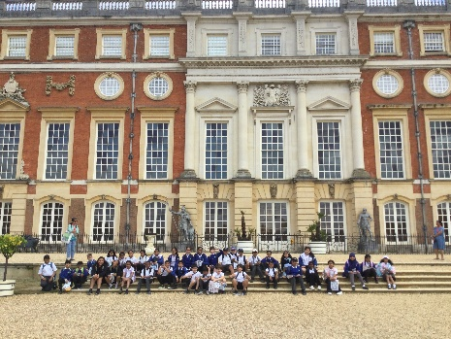
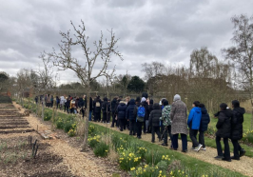
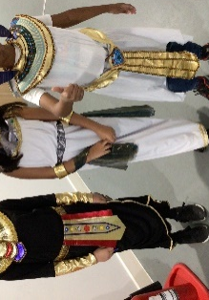
Our curriculum in Year 5 is rich, varied, and designed to spark curiosity and a love of learning! Through our Stargazers topic, children explore the wonders of space, learning about the solar system, the phases of the moon, and the lives of astronauts. In Pharaohs, we step back in time to Ancient Egypt, uncovering the secrets of the pyramids, mummification, and life along the Nile. The Allotments topic helps children to understand animals and their habitats, the importance of sustainable living, and how plants grow. In the Summer Term we look at the Tudors, where we learn about kings and queens, daily life in Tudor times, and the dramatic changes that shaped modern Britain.
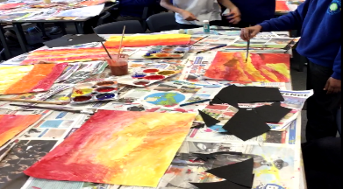
We believe that learning should be engaging and memorable, which is why we enrich our curriculum with a range of educational visits and workshops. Children will take part in a hands-on science workshop focused on forces, deepening their understanding of motion, gravity, and friction. Our Ancient Egypt workshop brings history to life through artefacts, role play, and interactive activities. During our trip to a local kitchen garden, pupils will explore how food is grown and develop an appreciation for nature and healthy eating. A highlight of the year is our visit to Hampton Court Palace, where children walk in the footsteps of Henry VIII and experience life in a real Tudor palace.
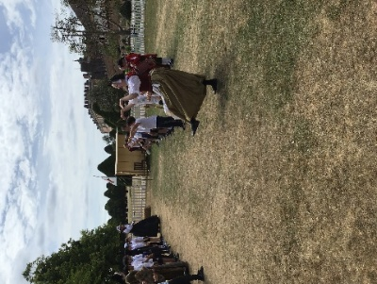
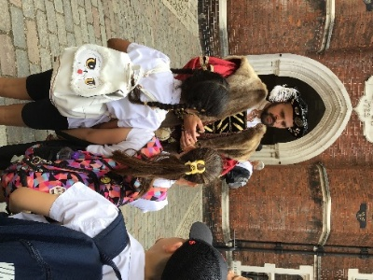
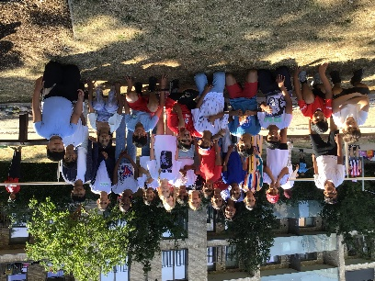

Year 5 is a time for growing independence, building resilience, and developing the skills needed for success in Year 6 and beyond. Children are encouraged to take ownership of their learning, work collaboratively with their peers, and embrace new challenges with confidence.

