Year 6 at Hounslow Town Primary School
Preparing the children for SATs
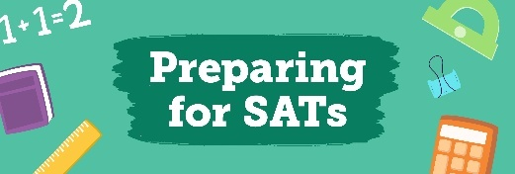
In Year 6, staff and children work hard from the very beginning of the academic year to prepare the children for their KS2 SATs. We complete a baseline assessment for all children when they return to school in September to ensure we can appropriately allocate them to streamed Maths and Reading groups. This allows children to work at a pace that is suitable for them and enables teachers to plug gaps that are identified in their groups. We also offer boosters, which effectively develop the children’s knowledge and understanding of key concepts. These are delivered by experienced members of staff. Alongside this, it is important for us to reinforce the importance of a good routine, and this is done through our parent workshop and PSHE sessions.

End of year experiences
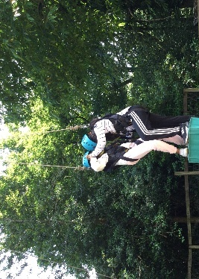
Year 6 is not only about preparing the children for SATs. We take pride in the number of experiences we provide the children with. We recognise that this is the ‘end of an era’ for all of our Year 6 children and we thoroughly enjoy celebrating marking the end of their primary school journey with them. From our residential trip to our end of year production and the signing of shirts and autograph books, we ensure that all children have the opportunity to come together with their peers and not say ‘goodbye’, but ‘see you later’. Some of the end of year trips that children have previously enjoyed consist of ‘Flip Out’ in our local area and Marble Hill Park in Twickenham.
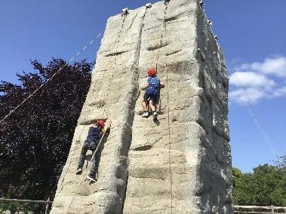
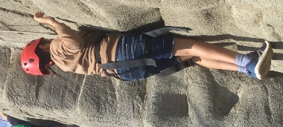

Transition
All staff in Year 6 recognise that the transition from primary to secondary school can be overwhelming for both parents/carers and children. From the very beginning of the year, secondary schools are invited to visit our Year 6 children to share information about their school. These visits include discussions around teaching and learning, clubs and extra-curricular activities and the many opportunities they have on offer. Children are encouraged to visit a range of secondary schools with their parents/carers to identify which school is best for them. As we move towards the end of the year, the children partake in a range of PSHE lessons, which explore how to cope with the transition from primary to secondary school. We offer coping strategies and support children to identify how to manage this change.

