Year 1 at Hounslow Town Primary School
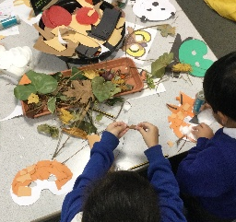
Year 1 at Hounslow Town Primary School is seen as a crucial transition year between the Early Years Foundation Stage (EYFS) and the more structured learning in Upper KS1 and KS2. We believe that maintaining a more informal and flexible provision during this period enables our children to build on their early experiences and develop into confident, independent learners. This foundation prepares them well for the more formal style of learning that follows.
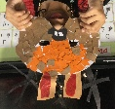
Our curriculum is centred around exciting, cross-curricular topics, underpinned by high-quality key texts. These carefully chosen texts provide meaningful context, helping children understand the purpose of their learning and make clear connections between subjects. These links deepen understanding and support long-term retention, enabling children to know more and remember more.
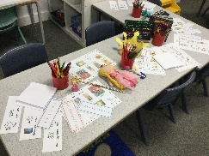
Across the week, children receive ten structured teaching inputs—six focused on English and maths, and the remaining four dedicated to other subjects. Each day, pupils engage in a balance of adult-led and independent activities. These independent tasks allow children to consolidate and apply the skills and concepts they have been taught.
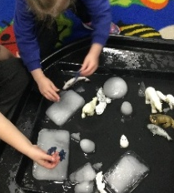
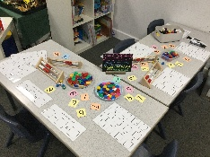
Subjects such as history, geography, science, art, design technology, and computing are taught discretely, yet linked through the core text, creating a cohesive and meaningful learning journey. While maths, based on the White Rose scheme, is not thematically linked, our approach ensures children have opportunities to consolidate their mathematical understanding and demonstrate their knowledge through independent application.

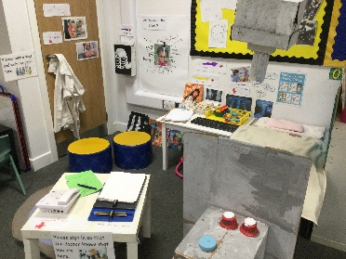
The Learning Environment
In our Year 1 classrooms, you will find children actively engaged in a wide variety of learning tasks that complement and reinforce each other. Alongside daily English and maths lessons, children participate in creative activities, role-play, and hands-on subject-based learning.
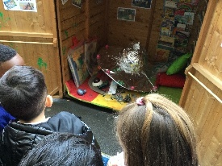
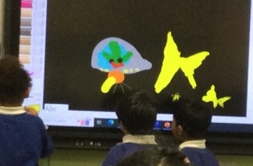
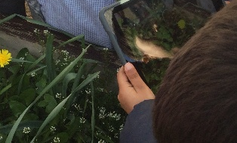
Our learning provision extends beyond the classroom to include an outdoor learning area as well as our dedicated 'busy learning area'. These spaces provide all children; particularly those without prior EYFS experience, learners with limited English, or children with SEND, the opportunity to access the curriculum in meaningful, practical ways. At the same time, these areas offer problem-solving opportunities that challenge and extend higher-attaining pupils.

Support and Feedback
Our teaching model ensures that every child works with both the class teacher and teaching assistant across the curriculum. This enables targeted support for those who need it, while also providing stretch and challenge for those ready to move forward.
Marking and feedback is conducted alongside the children during learning time, allowing for immediate responses to next steps when they are most impactful and relevant.

Why This Approach?
This approach builds seamlessly on the play-based learning that children experience in Reception. It provides flexibility and adaptability; particularly important for younger children, those with additional needs, and those with English as a second language, allowing each child to navigate the learning environment in a way that supports their individual growth.
It supports the holistic development of our children; cognitive, social, emotional, and physical, laying a secure foundation for future academic achievement and lifelong learning.


