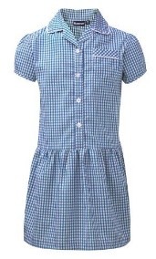
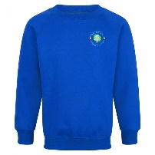
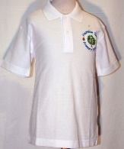
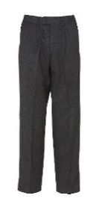
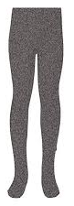
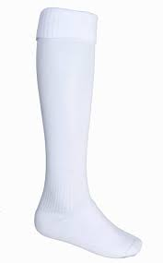
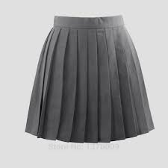
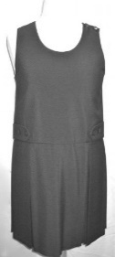
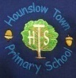
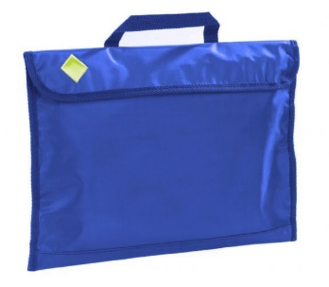
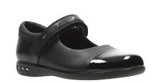
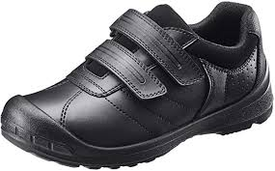
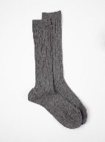
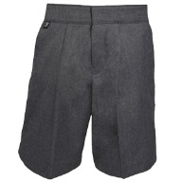
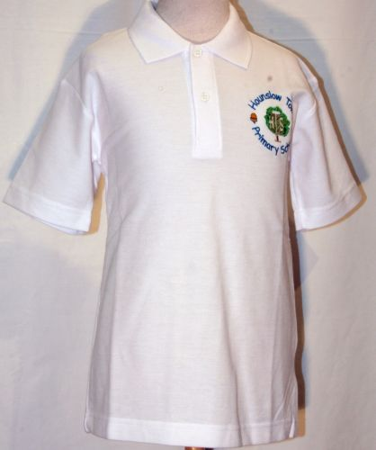
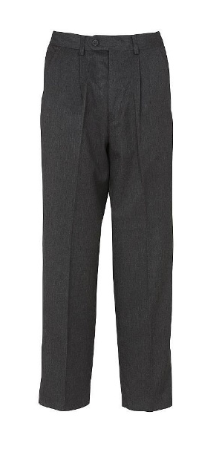
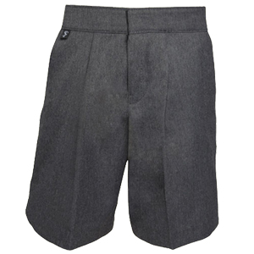
Uniform

We expect all children to wear correct school uniform at all times, including suitable school shoes in black, preferably with a Velcro fastening. Children will be outside most days, regardless of the weather, so please make sure they have a warm coat in the winter and a waterproof coat for rain. Please provide a sun hat for the warmer weather. Children should not wear jewellery with the exception of small religious items. Small stud earrings are the only acceptable earrings allowed. Nail varnish should not be worn.

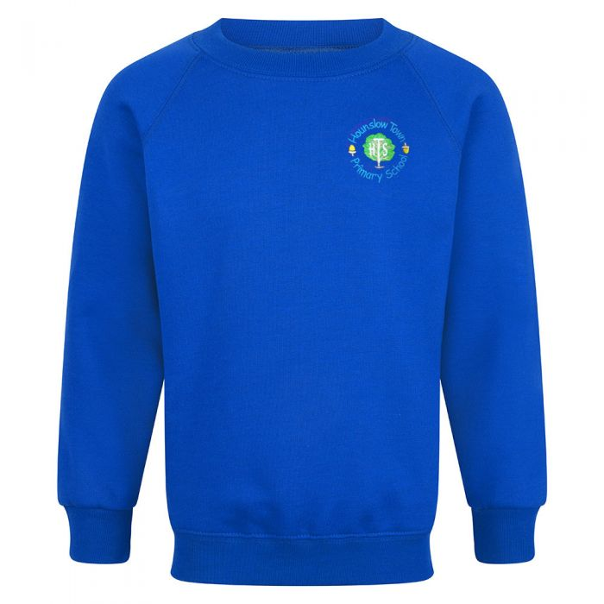

Our boys may wear grey trousers (or shorts in Summer); a white shirt or polo shirt; a Hounslow Town blue sweatshirt; grey socks and black shoes.

Our girls may wear a grey skirt, pinafore dress or trousers; a white shirt or polo shirt; a Hounslow Town cardigan or sweatshirt; white socks; white or grey tights; black shoes.

A PE kit is not required for Nursery children. Reception children will require a PE kit in the summer term. Please refer to the insert attached in this prospectus for more information.

Please note:
Children wishing to wear religious head scarfs are encouraged to do so but it is requested that the colours are the same as that of the school uniform.

All our school uniform is available from:
School Bells, 48 Bell Road, Hounslow, TW3 3PB Phone number: 020 8577 6656
Sanco, 60 Bell Road, Hounslow, TW3 3PB Phone number: 020 8570 9990

